Jobic
" Work transition has never been easier"

- Introduction
- Site suggestion
  - The problem we are solving
  - The value we suggest
  - Our competitive advantage
  - Target Users
  - Persona
- User Stories
- Use Cases
- Entities
- Information System Tree
- Mockups
- Screens
- Axure Link : https://wcgh23.axshare.com

Introduction:

Company name: Jobic
vision: Streamline the job search process
Goal: In 5 years Jobic will be the favorite Add-on plugin for job search platform

Site suggestion:
A job seeker application that provides various tools to streamline the search process

The problem we are solving
A Job seeker in the Israeli Hi-Tech market is flooded with Job interview on one hand and has little time on the other hand, he needs a reliable tool to be able to manage his resources and make the best of his time
Today, all the Job Hunt sites provide a poor solution for the job hunt process itself and offer insufficient solution for tracking the Interviews\offers\ CV sent procedures that are essential in the job hunt process

The value we suggest
A solution that focuses on the job search process itself and provides the user with the tools required in the process to get the best job offer for him

Our competitive advantage
Providing an overall solution for the process side

More information in Appendix 1

Target Users
An active job seeker – male/female ages 20-60 that are actively looking for a job in the Israeli hi-tech scene

Persona:
- a Job seeker
- HR recruiters

User Stories:

Job seeker
- As an active job seeker, I want to be able to track my job interviews details and follow-ups interviews so that I can keep track on all the offers

- As an active job seeker, I want to keep track all the places I send my CV and their replies to so that I can monitor my progress

- As an active job seeker, I want to obtain the maximum information before a job interview so that I can maximize my chances to get the job

- As an active job seeker, I want to be able to consult with other active Job seekers so I will be able to be ready to an interview

HR recruiters

- As an HR recruiter I want to be able to contact an active Job seeker so I can offer him a Job
- As an HR recruiter I want to view an active Job seeker profile so I can offer him a Job from my list
- As an HR recruiter I want to in order to:
- As an HR recruiter I want to in order to:

Use Cases:
Active Job Seeker profile:
- User Login \ Signup to his account
- User Creates a personal Job seeker profile, expose relevant information about his Job search:
- User Name
- Job title
- experience and expertise
- links to public profiles
- Add CV file \ files (user may have more than one CV file)
- Add Cover Letter \ Letters (user may have more than one cover letter file)
- User Can Manage the process of sending CV - CV tracking system:
Add a company he sends to including these details:
- Company name
- Company Site
- Employees Number
- Location
- email address,
- the source\link of this job (Facebook/job hunt sites / friends, company site / newspaper)

When Sending CV to a company – add a "Send" entity with the following:
- Link to Company entity
- Link To CV version Sent
- Link to Cover letter Sent
- Specify the Suggested Role
- Add the date
- Add Email
- Add Description or comments

- Start a Job process – in case the user heard back from the company he needs to start a work process with the following details:
- Company (name of id)
- To which Job title
- Contact Person
- Link to CV version that was sent
- And some description if needed

If an Interview was organized (phone call or in person) he Adds an Interview with the following details:
- Type (phone/video/in person/home task)
- Meet with
- His Job Title
- Schedule time
- Location
- Contact person (the one that set up the meeting)
- Purpose (meet with HR – professional interview etc.)
- Description (if needed)
- Summary – will be updated at the end of the meeting

When there is a follow-up interview – User will add more new interviews to the same Job Process.
User need the ability to Close and Interview branch:
- Status filed indicate if this Job process is active or not
- If the status will change to close – need to add the closing Reason

- User will have the ability to monitor all the active processes and CV sending status using Dashboards on the main page

Manage " Questions from job interviews" (community/forum) so users can share their knowledge on the questioned being asked in specific company:
- Link Question to company
- Ability to add a question
- Ability to add a solution to a question (there could be mote then one solution)
- Ability to add comment to a solution
- Search option (different filters: by company \ by subject etc.)
- Link to job hunt sites (maybe get data from them?)

- Create a smart agent on a company on a job hunt sites – so if a Job I desire will pop up I will get notification.

HR recruiters
Need to be done ….

Entities
Interview
Interview No.
Type
Meet With
Job Title
Location
schedule time
Contact person
Purpose
Description
Summary

Job Process
Process ID
Company ID
Job Title
Contact person
Description
CV Version
Status
Reason
Interviews List

User Profile
Name
Login
Password
List of Expertise
List of Searches
Location
Location
List Of public profiles
List of Job Processes

Company
Company ID
Name
Domain
Location
Description
Web Site
Employees No.

Material
Material No.
Description
Source
File\Link

CV Versions
CV Version
To Job Title
Description
File

Cover Letter
Cover Letter No.
To Job Title
Description
File

CV Sent
Company ID
CV Version
Cover Letter No.
Date
To Role
Link To Source
Email
Description

Interview Question
Question No.
Company ID
To Role
Date
Title
The question
Author (User)
Solutions List

Solution
Solution No.
Question No.
Linked To Solution No.
Author
Solution
Comments

Information System Tree
Home Page
Sign In/
Sign Up

User Profile
Dashboard
Interview Question
External Material /Resources
Companies
Job Process
CV Versions
Cover Letters
Interview
Mockups

Home / Landing Page
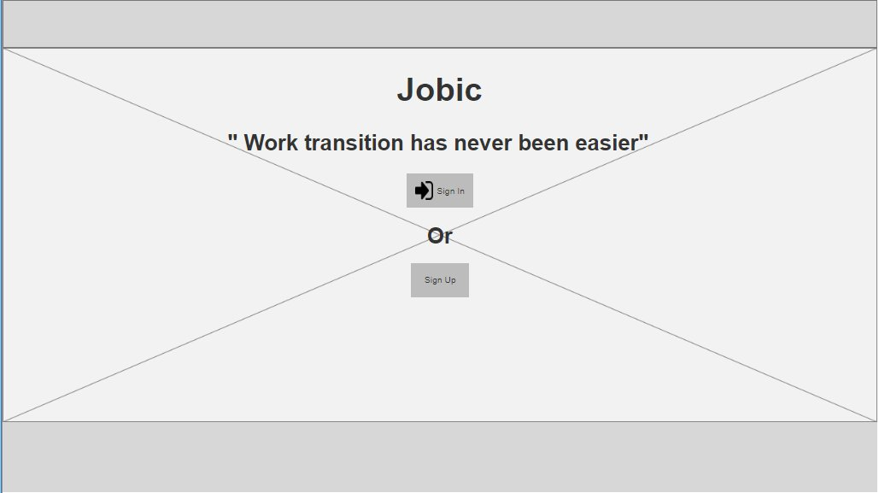

Registration Form
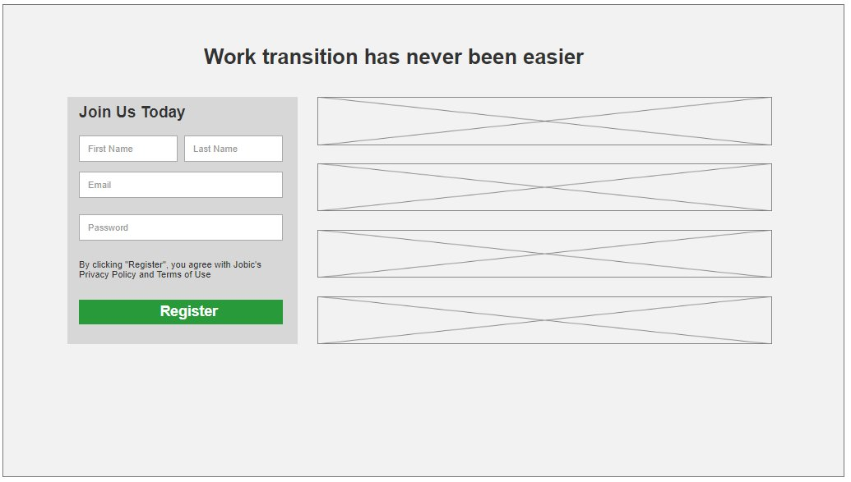

Dashboard
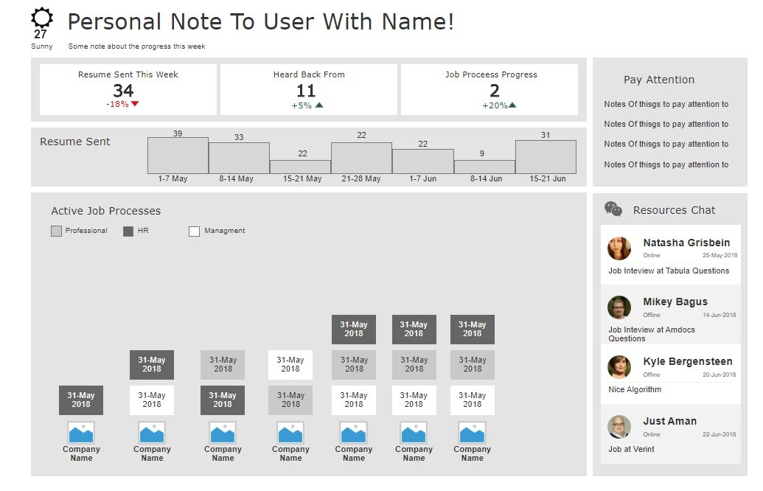

Screens:
Register
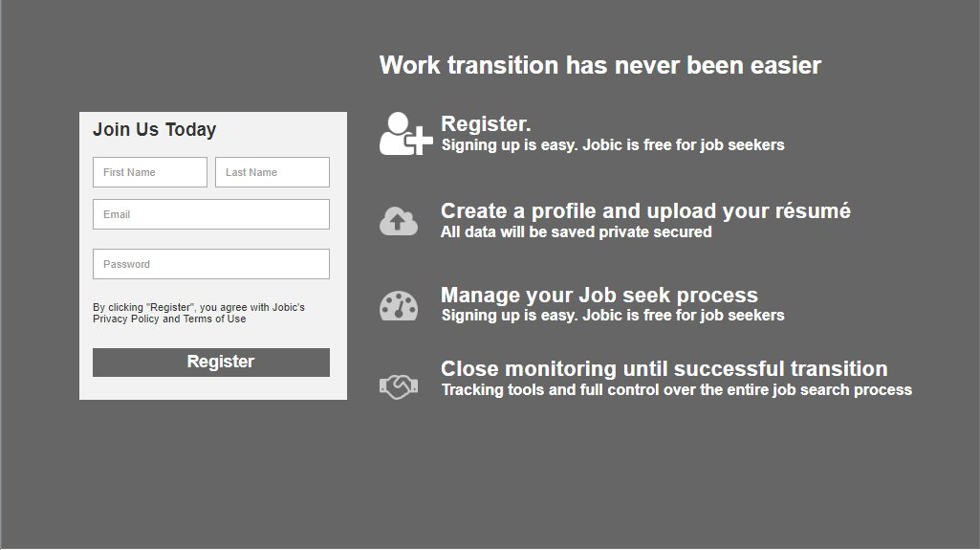

User profile Page

Appendix 1

What are we aiming for
What will we do at each stage
What are we not going to do

Marked research:
In Israel Hi-tech job hunt ' the following application provide solutions:
looking in Israeli web sites :
https://www.alljobs.co.il/
https://www.drushim.co.il/
https://www.jobnet.co.il/
https://www.jobmaster.co.il/
https://www.linkedin.com/feed/?trk=
https://www.geticv.com/
https://www.thebalancecareers.com/best-job-search-engine-sites-2061906
https://www.careerbuilder.com/
https://www.dice.com/
https://il.indeed.com/?r=us
https://www.idealist.org/en/?type=JOB
https://www.monster.com/
https://www.ziprecruiter.com/

list taken from :
https://www.thebalancecareers.com/top-best-job-websites-2064080

https://helpdesk.thrivist.com/hc/en-us/articles/226493928-What-Information-is-on-My-Learner-Dashboard-
https://dribbble.com/shots/2859111-Dashboard-Template-work-in-progress

Business model (where the money will come from)
- Banner ads
- Add-Free solutions
- Freeminum

Interview Question
Question No.
Company ID
To Role
Date
Title
The question
Author (User)
Solutions List

Solution
Solution No.
Question No.
Linked To Solution No.
Author
Solution
Comments

CV Sent
Company
CV Version
Opening letter\Cover Letter

